Castles

Kate Machin

Contents

Introduction 2

Main information 3

Rooms in a castle 4

Entertainment 5

Food and feasting 6

Weapons and punishment 8

Conclusion 11

Bibliography 12

Introduction

I am writing about what happens in different rooms of a castle. The people that lived in the castle would be the lord and the lady, also there would be all of the servants and there would also be children living there.

Why?

The Normans built castles very quickly because they needed them to get protection. They also built castles for fortification, which is strength.

Where?

The castles were built on high ground. This was because it had a good look out view to see if their enemy was coming but also it meant that when the enemy came it had to walk up the hill to get to the castle.

How?

The castles were built out of wood to begin with and then they were built out of stone. The walls of a castle have to be very strong to stop them being bombarded by catapulted rocks.

Main Information

In Medieval times the castles were very big and here is some information on them.

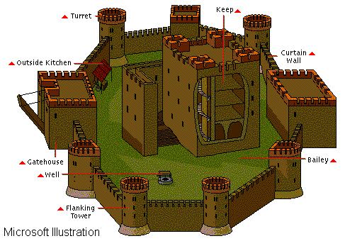
This is a motte and bailey castle. It has this name because it was built on a mound or motte, which is a large hill. It also has the name bailey because it has a bailey in the grounds of the castle. The bailey is a place were all the soldiers live that they fight for the King.

The keep on the castle is where the King puts his jewels and all his belongings when they are under attack. The King also goes in there when he is under attack. The keep is also a form protection against the enemy.

The well is where the cook gets the water they need for cooking with. The servants also get water for the king.

Rooms in a castle

Living like a Lord

When you lived like a Lord you got lots of lovely riches like a personal servant or lots of lovely gems.

The rooms a Lord lived in

The Lord had his bedroom that was very spectacular. In his room it had a massive bed with a big canopy over it. At the end of the Lord's bed there would be a chest with plates in it because buying plates was like saving to the medieval people. This was because the plates could be melted down and could be sold if they were short of money. The Lord would also have his own chapel where he would go and pray. In the castle there would be a treasury and counting room.

Children of the castle would have lessons from the chaplain because he was the best-educated person in the castle. Children learnt to read, write and sometimes learnt Latin. When a baby was born they had nurses to look after them. When your dad was a Lord you didn't marry for love you married because the sons and daughters had to marry each other.

The castle had toilets that were just hole in a piece of wood and they didn't have any plumbing as such so all of the waste went down a hole and then into the bottom of the moat. The waste would build up at the bottom of the moat.

The Lord spent a lot of money on expensive food and lovely embroidered wall hangings. Also money was spent on beautiful clothes, gold or silver and entertaining guests.

In the castle grounds there was a stable where the horses were kept.
Entertainment

All of the people who lived in the castle enjoyed entertainment and games.

Here are some of the games and entertainment that were used.

A game that might have been played was jousting, which is a game where two knights would have lances and they would charge at each other with their lances pointing at one another. They would fight for his lady. In the castle there would be a formal garden where ladies might sit and talk. They would probably have a gardener to do all of the gardening.

A game that we say would be cruel today was not thought cruel in medieval times. Bear baiting is a game where people pay to watch their dogs fight a chained up bear. If the bear yelped the dog's owner would win some money and if the dog yelped they got nothing.

The entertainment or games for children would be a puppet show, playing knights and playing with tops.

In the grounds there would probably be a fortuneteller, a pedlar, a wrestling match, ferret kennels, cock fighting which is cocks fighting and an herb garden.

People would be preparing dogs for a boar hunt.

Food and feasting

Food and feasting took place in the hall because it was the biggest room. When the King held a feast everyone sat on benches except the King.

When there was a feast they had table manners and here are some useful tips from 15th-centuary manuscript.

- Do not spit upon or over the table.

- If you wash your mouth out while at the table do not spit the water back into the bowl, but instead spit politely onto the floor.

- If there is a man of God (such as a priest) at the table, take special care where you spit.

- Do not pick your teeth at the table with a knife, straw or stick.

- Do not belch near anyone's face - if you have bad breath.

When the food is prepared it is done in a separate building which is outside. Meat was cooked on a spit, which was over the fire.

Some of the foods they ate were roast peacock, wild boar's head, cooked dolphin and sugar castle, which is a castle made out of sugar. The spices they ate were very expensive. The spices they ate were cloves, buckwheat, ginger, coriander, cinnamon, cumin, aniseed, liquorice and pepper.

The castle had a food taster that sampled every dish to see if there was any poison in them. (I bet they had to employ a lot of those!)

Dover Castle

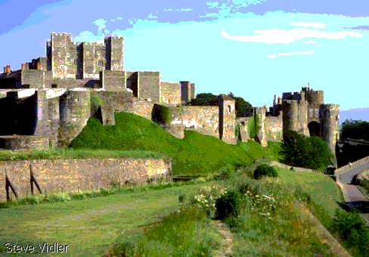

Dover castle is a medieval castle.

Weapons and punishment

A separate part of the castle was used for storing weapons and where villains were punished.

Weapons

Some of the weapons kept there were crossbows, arrows, catapults, stones, lance, shield, ball and chain and longbows.

Crossbows
Crossbows were very powerful bows and people were afraid of them. It was the medieval equivalent of an atom bomb.

Arrows
Arrows were very sharp points made out of iron. That was on top of a piece of wood.

Stones
Stones were used for throwing at the enemy.

Longbows
Longbows were used for firing arrows and the strings were kept on the wall.

Lances
Lances are long sticks with points. They were used for fighting by trying to knock other people of their horses.

Catapult
A catapult is a large wooden frame on wheels and was used to throw large stones at people trying to invade the castle.

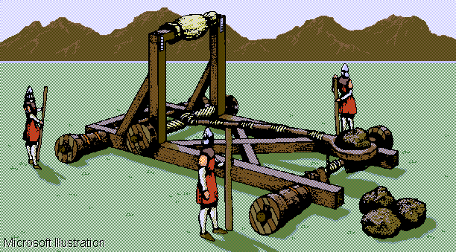
Shield
A shield was used for protection over the face and they used it for hitting people with.

A ball and chain
A ball and chain is used for hitting people. It is also very lethal because it had spikes.

Punishment

Punishment comes in different shapes and sizes. Sometimes it can be very gory. Some examples are:

Victim being cut up

Ducking - being plunged into the water.

Finger Pillory - the prisoner trapped by the fingertips.

Pressing - being pressed down by weights.

Hanging in chains - hung by chains in mid air in the nude.

Bodium castle

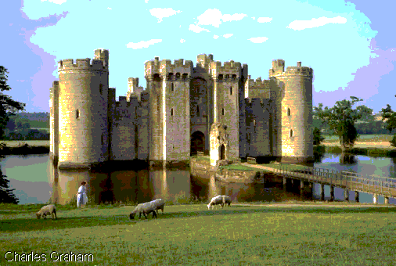
Bodium castle is a medieval castle.
Conclusion

Living in a castle would be very different from living in my own house because the castle is like a village with all the tradesmen and livestock living there. If a castle was under attack they had everything they needed to survive for a little while within the castle walls. Working in a castle was very hard work because there were so many jobs to do, particularly at harvest time and with so many people living within the castle they had to make sure they had enough food.

I think that it would be very different living in a medieval castle than living in my own house.

It would be very dark and not very warm. They did not have any electric bulbs and had to rely on candles. I don't think I would like to live in a house without running water and proper toilets.

It is also very big and you might lose your way around.

Bibliography

Encarta 96 Encyclopaedia

Cross-sections castle
Author = Stephen Biesty

Medieval Britain
Author = Brenda Williams

